FOOD DELIVERY ANALYTICS

PROJECT OVERVIEW
This project analyses food delivery data using **Google sheet, SQL,Python and Power BI**. The goal was to clean messy data, analyze business performance and create an interactive dashboard to help management make data-driven decisions.
This project simulates a real-world food delivery business where data contains missing values, inconsistent text that require cleaning before analysis.
---
BUSINESS PROBLEM
The company wanted answers to the following questions:
- Which restaurant earned the highest revenue?
- Which city placed the most orders?
- Which restaurant has the highest average rating?
- Which payment method is used the most?
- Which are the top 3 restaurants by revenue?
- Which food category generates the highest revenue?
- Which restaurants have an average rating above 4.3?
- What is the average order value?
- Which city has the fastest delivery time?
---
TOOLS USED
- Google Sheet
- SQL (BigQuary)
- Python (Pandas and Matplotlib)
- Power BI
---
DATASET
The dataset contains food delivery orders with the following columns:
- order_ID
- restaurant
- city
- food category
- delivery_time
- order_amount
- payment_method
- rating

The dataset intentionally included:
- Missing values
- Inconsistent city names
---
SPREADSHEET (DATA CLEANING)
Performed the following cleaning steps:
- Identified missing values by conditional formatting
- Standardized city names
- Standardized restaurant names
- Standardized payment methods
- Filled missing values by replace it with the avg of the same column
---
SQL ANALYSIS
Used SQL to answer business questions including:
- Revenue by restaurant
- Orders by city
- Average rating by restaurant
- Average delivery time by city
- Payment method analysis
- Top 3 restaurants by revenue
- Revenue by food category
- Restaurants with rating above 4.3
- Average order value
- Fastest delivery city

SQL CONCEPTS USED
  - SELECT
  - FROM
  - WHERE
  - GROUP BY
  - ORDER BY
  - HAVING
  - LIMIT
  - SUM()
  - AVG()
  - COUNT()
---
PYTHON EXPLORATORY DATA ANALYSIS
Performed:
- Dataset overview
- Summary statistics
- Rating distribution
- Correlation analysis
- Top expensive orders
- Restaurant revenue analysis
- Payment method analysis
- Histograms
- Scatter plots
- Bar charts
- Pie charts

PYTHON LIBRARIES
- Pandas
- Matplotlib

PYTHON CONCEPTS USED
  - read_csv()
  - head()
  - info()
  - describe()
  - value_counts()
  - groupby()
  - sort_values()
  - nlargest()
  - corr()
---
POWER BI DASHBOARD
Created an interactive dashboard containing:
KPI Cards

- Total Revenue
- Total Orders
- Average Rating
- Average Delivery Time

Charts

- Revenue by Restaurant
- Orders by City
- Revenue by Food Category
- Payment Method Distribution
- Average Rating by Restaurant

Filters

- City
- Restaurant
- Food Category
--

DASHBOARD OVERVIEW
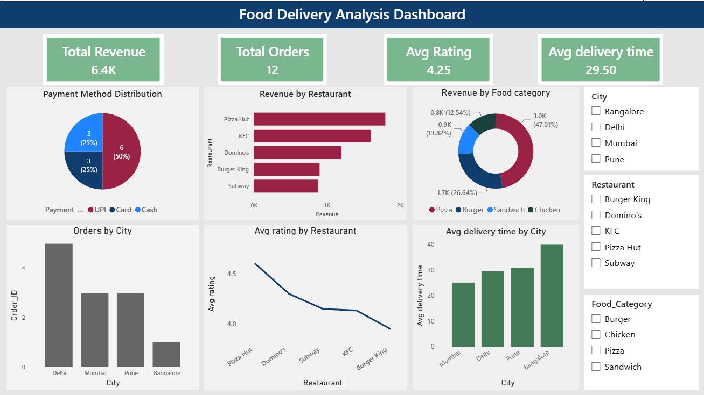

KEY INSIGHTS

- Pizza Hut had the highest revenue generating restaurant
- Delhi city placed the most orders
- Pizza Hut had the average ratings across restaurants.
- Mumbai city had the fastest delivery performance compared to Banaglore
- UPI was the most preferred payment method.
- Pizza had the highest revenue food category across cities.
- Delivery times effect on average rating, positive if reached on time and negative with low rating.
---

Author
Sneha Sharma

